SIMATS ENGINEERING (SAVEETHA SCHOOL OF ENGINEERING)
Department of Computer Science and Engineering
ASSESSMENT TOOL 3 – Comparative Analysis
Course Code: | CSA06 | Course Title: | Design and Analysis of Algorithms
CO Assessed: | CO4: Articulation (BL4, BL5) | Assessment: | Assessment Tool 3 – Comparative Analysis
Weightage: | 10% of CIA | Total Marks: | 100 (2 Questions × 50 Marks)
CO4 Statement: | Solve optimization problems using dynamic programming and greedy strategies.
Student Name: | A M RAKESH | Reg. No.: | 192424393
Section / Batch: | AIDS/24 | Date: | 22/08/2026

Instructions to Students
- Answer both questions carefully. Each question carries 50 marks. Total: 100 marks.
- Analyze the given questions thoroughly before answering.
- Compare multiple aspects such as methods, results, advantages, and limitations clearly.
- Critically evaluate the strengths, weaknesses, and implications with proper justification.
- Present meaningful insights, interpretations, and well-supported conclusions from the comparisons.

Question Type | Description | Questions | Total Marks
Comparative Analysis | Focus on Comparison of different Algorithms using dynamic programming and greedy strategies. | Q1 – Q2 | 100

SECTION A – Comparative Analysis
1.Bellman-Ford vs Dijkstra (DP vs Greedy)
Given a weighted graph with negative edges, compute shortest paths using Bellman-Ford and Dijkstra. Compare correctness and performance. Analyze why Dijkstra fails for negative weights. Evaluate complexity differences. Discuss real-world applications. Generate insights on shortest path algorithm selection
- Define the Word Break and Longest Palindromic Subsequence problems with suitable examples.
Word Break Problem
Given a string $s$ and a dictionary of strings wordDict, determine if $s$ can be segmented into a space-separated sequence of one or more dictionary words.

Example: $s="applepenapple"$, $wordDict=["apple","pen"]$
Output: True (Segmented as $"apple"+"pen"+"apple"$)

Longest Palindromic Subsequence (LPS)
Given a string $s$, find the maximum length of a sequence of characters derived from $s$ (without changing their relative order) that reads the same forwards and backwards.
Example: $s="bbbab"$\
Output: $4$ (Subsequence $"bbbb"$)

- Write the DP algorithm or pseudocode.

Algorithm WordBreak(s, wordDict):
n = length(s)
dp = array of size n + 1 initialized to False
dp[0] = True // Empty string base case

for i from 1 to n:
for j from 0 to i - 1:
if dp[j] is True and substring(s, j, i) is in wordDict:
dp[i] = True
break // Stop checking earlier substrings for position i

return dp[n]

- Prepare the DP table/state representation.

1. Word Break Problem

State Representation:
$dp[i]$ is a boolean value indicating whether the prefix string $s[0 \dots i-1]$ (length $i$) can be segmented into dictionary words.
Base Case: $dp[0]=True$ (empty string).
Transition: $dp[i] = \bigvee_{0 \le j < i} (dp[j] \land s[j \dots i-1] \in \text{wordDict})$
DP Table Example: $s="leetcode"$, $wordDict=["leet","code"]$

Index i | 0 | 1 | 2 | 3 | 4 | 5 | 6 | 7 | 8
Prefix $s[0 \dots i-1]$ | "" | "l" | "le" | "lee" | "leet" | "leetc" | "leetco" | "leetcod" | "leetcode"
$dp[i]$ | T | F | F | F | T | F | F | F | T

2. Longest Palindromic Subsequence (LPS)

State Representation:
$dp[i][j]$ stores the length of the longest palindromic subsequence in substring $s[i \dots j]$.
Base Cases: $dp[i][i]=1$ (single characters), $dp[i][j]=0$ for $i>j$.
Transition:
$$dp[i][j] = \begin{cases} dp[i+1][j-1] + 2 & \text{if } s[i] = s[j] \\ \max(dp[i+1][j], dp[i][j-1]) & \text{if } s[i] \neq s[j] \end{cases}$$
DP Table Example: $s="bbbab"$
i\j | 0 (b) | 1 (b) | 2 (b) | 3 (a) | 4 (b)
0 (b) | 1 | 2 | 3 | 3 | 4
1 (b) | 0 | 1 | 2 | 2 | 3
2 (b) | 0 | 0 | 1 | 1 | 3
3 (a) | 0 | 0 | 0 | 1 | 1
4 (b) | 0 | 0 | 0 | 0 | 1

- Develop the recurrence relation
1. Word Break Problem

$$dp[i] = \bigvee_{j=0}^{i-1} \left( dp[j] \land \big(s[j \dots i-1] \in \text{wordDict}\big) \right)$$
Base Case: $dp[0]=True$
Target: $dp[n]$ (where $n=len(s)$)

2. Longest Palindromic Subsequence (LPS)

$$dp[i][j] = \begin{cases} 2 + dp[i+1][j-1] & \text{if } s[i] = s[j] \text{ and } i \neq j \\ 1 & \text{if } i = j \\ \max\big(dp[i+1][j], \; dp[i][j-1]\big) & \text{if } s[i] \neq s[j] \end{cases}$$
Base Case: $dp[i][i]=1$, and $dp[i][j]=0$ for $i>j$

Target: $dp[0][n-1]$

- Implement the Longest Palindromic Subsequence using Dynamic Programming (Saveetha Compiler)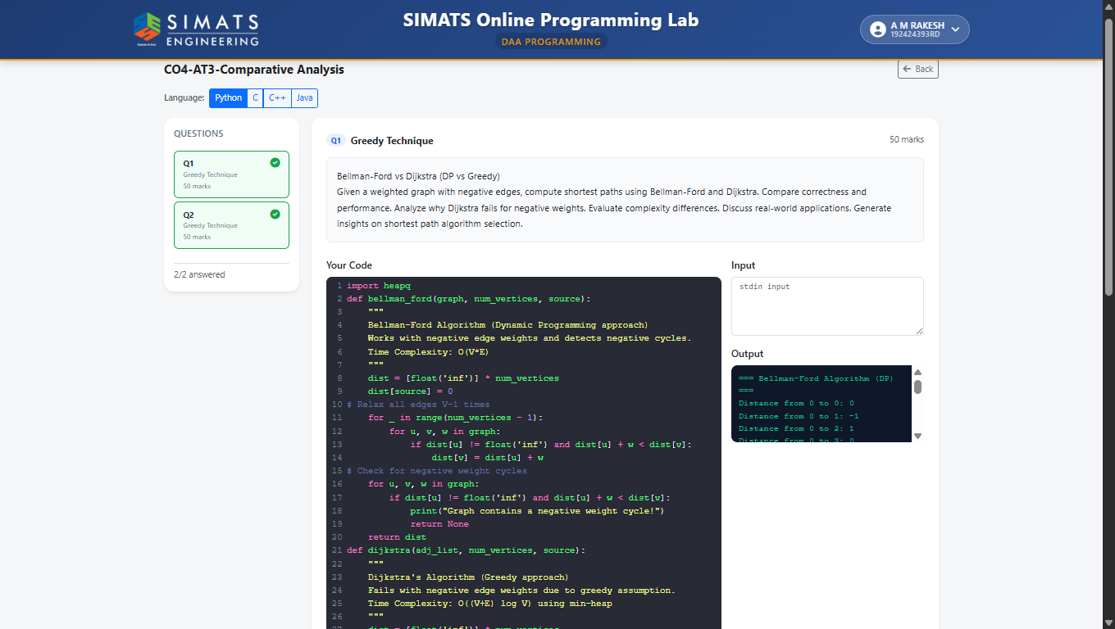
- Analyze time complexity.
Bellman-Ford Complexity
Time: O(V⋅E)
Reason: Relaxes all ∣E∣ edges over ∣V∣−1 outer iterations, plus 1 final pass for negative cycles.

Word Break Complexity
Time: O(N2⋅K) (or O(N2) if word length K is bounded)
Reason: Two nested loops over string length N combined with O(K) substring extraction and hash lookup.

LPS Complexity
Time: O(N2)
Reason: Fills half of an N×N DP table (2N2​ subproblems), taking O(1) constant time per cell update.

- Analyze space complexity.
Bellman-Ford Space Complexity
Space: O(V)
Reason: Requires an array of size ∣V∣ to store distances from the source to each vertex.

Word Break Space Complexity
Space: O(N)
Reason: Uses a 1D boolean DP array of size N+1 to store prefix validity.

LPS Space Complexity
Space: O(N2) (Optimizable to O(N))
Reason: Uses an N×N 2D DP matrix to store substring palindrome lengths.

- Compare the two DP formulations using a table.

Feature | Word Break | Longest Palindromic Subsequence (LPS)
DP Structure | 1D Array (dp[i]) | 2D Matrix (dp[i][j])
State Definition | Can prefix $s[0 \dots i-1]$ be split into valid words? | Max palindrome length in substring $s[i \dots j]$
Table Size | $1×(N+1)$ | $N×N$
Transitions Per Cell | Checks all split points $j<i$ ($O(N)$ operations) | Constant comparison of endpoints ($O(1)$ operations)
Base Case | dp[0] = True (empty string) | dp[i][i] = 1 (single characters)
Space Complexity | $O(N)$ | $O(N^{2})$ (Optimizable to $O(N)$)
Time Complexity | $O(N^{2}⋅K)$ | $O(N^{2})$

- Identify similarities between the two problems.
Optimal Substructure: Both break down a larger string problem into solutions of smaller, overlapping substring subproblems.
Overlapping Subproblems: Both use DP tables to memoize previously calculated substring states, avoiding exponential recomputation.
String-Based Input: Both operate on a single input string of length N.
Quadratic Time Complexity: Both run in O(N2) time by evaluating combinations of indices (i,j).
Decision-Making via Substrings: Both determine global properties by testing whether smaller contiguous segments satisfy specific rules (dictionary match vs. equal endpoint characters).

- Identify differences in state definition and transitions.

Feature | Word Break | Longest Palindromic Subsequence (LPS)
State Dimension | 1D (dp[i]) representing string prefixes. | 2D (dp[i][j]) representing internal substrings.
State Meaning | Boolean (True/False): Is prefix $s[0 \dots i-1]$ valid? | Integer: Length of the longest palindrome in $s[i \dots j]$.
Transition Dependencies | Looks back at all prior valid splits $j<i$. | Looks only at adjacent subproblems ($dp[i+1][j-1]$, $dp[i+1][j]$, $dp[i][j-1]$).
Transition Logic | Logical OR over word lookups: $dp[j] \land (s[j \dots i-1] \in \text{Dict})$. | Conditional MAX: $+2$ if $s[i]==s[j]$, else $\max_{→}(left,down)$.

- Compare the DP state, transition, implementation, and complexity of both problems and provide a conclusion.

Feature | Word Break | LPS
State | dp[i] (1D): Can prefix $s[0..i-1]$ be segmented? | dp[i][j] (2D): Max palindrome length in $s[i..j]$.
Transition | $dp[i]=True$ if $dp[j] \land s[j..i-1] \in \text{Dict}$ | Match: $dp[i+1][j-1]+2$  Mismatch: $\max_{→}(dp[i+1][j],dp[i][j-1])$
Iterate By | Increasing prefix length $i$ ($1 \to N$). | Increasing substring length ($2 \to N$).
Complexity | Time: $O(N^{2})$ | Space: $$O(N$ | Time: $O(N^{2})$ | Space: $$O(N^{2}$

2.Travelling Salesperson Problem Comparison (DP vs Greedy Heuristic)
Given 4 cities and distance matrix, solve TSP using DP and nearest neighbor greedy approach. Compare total tour cost and computational effort. Analyze why greedy does not guarantee optimality. Evaluate exponential complexity of DP. Discuss scalability challenges. Generate insights on exact vs heuristic methods.
- Define the Word Break and Longest Palindromic Subsequence problems with suitable examples.

TSP: DP vs. Greedy (Nearest Neighbor)
Matrix: $A-B=10$, $A-C=15$, $A-D=20$, $B-C=35$, $B-D=25$, $C-D=30$.
Greedy: $A \to B \to D \to C \to A = \mathbf{80}$. Fast ($O(N^{2})$), but non-optimal because local choices force high cost later.
DP (Held-Karp): Finds optimal tour cost ($80$) in $O(N^{2}2^{N})$ time and $O(N2^{N})$ space. Blows up for $N>20$.
Insight: Use DP for exact answers on small $N$; use Greedy for fast approximations on large $N$.

Definitions & Examples
Word Break: Can string be split into valid words?
Example: "leetcode", ["leet", "code"] $\to$ True
LPS: Length of longest palindromic subsequence.
Example: "bbbab" $\to$ 4 ("bbbb")

- Write the DP algorithm or pseudocode.

Algorithm WordBreak(s, wordDict):
n = length(s)
dp = array of size n + 1 initialized to False
dp[0] = True

for i from 1 to n:
for j from 0 to i - 1:
if dp[j] is True and substring(s, j, i) in wordDict:
dp[i] = True
break

return dp[n]

- Prepare the DP table/state representation

1. TSP (Held-Karp)
State: $memo[mask][u]=$ min cost to visit the subset of cities represented by bitmask $mask$, ending at city $u$.
DP Table Layout: $2^{N}×N$ matrix.
Trace Example (4 cities: $0,1,2,3$; Start at $0$):
Mask (Binary) | Visited Cities | u=0 | u=1 | u=2 | u=3
0001 (1) | $\{0\}$ | 0 | $∞$ | $∞$ | $∞$
0011 (3) | $\{0,1\}$ | $∞$ | 10 | $∞$ | $∞$
0101 (5) | $\{0,2\}$ | $∞$ | $∞$ | 15 | $∞$
1111 (15) | $\{0,1,2,3\}$ | $∞$ | min cost | min cost | min cost

2. Word Break
State: $dp[i]=$ boolean indicating if prefix $s[0 \dots i-1]$ can be segmented into valid dictionary words.
DP Table Layout: 1D Array of size $N+1$.
Trace Example ($s="leetcode"$, Dict = ["leet", "code"]):
Index (i) | Prefix | dp[i] | Valid Match Found
0 | "" | True | Base Case
1–3 | "l", "le", "lee" | False | None
4 | "leet" | True | $dp[0] == \text{True} \land \text{"leet"} \in \text{Dict}$
5–7 | "leetc", "leetco", "leetcod" | False | None
8 | "leetcode" | True | $dp[4] == \text{True} \land \text{"code"} \in \text{Dict}$

3. Longest Palindromic Subsequence (LPS)
State: $dp[i][j]=$ length of LPS in substring $s[i \dots j]$.
DP Table Layout: $N×N$ Matrix.
Trace Example ($s="bbbab"$):
i\j | 0 (b) | 1 (b) | 2 (b) | 3 (a) | 4 (b)
0 (b) | 1 | 2 | 3 | 3 | 4
1 (b) | - | 1 | 2 | 2 | 3
2 (b) | - | - | 1 | 1 | 3
3 (a) | - | - | - | 1 | 1
4 (b) | -

- Develop the recurrence relation

1. TSP (Held-Karp)
Recurrence Relation:
$$memo[mask][v] = \min_{u \in mask, u \neq v} \Big( memo[mask \setminus \{v\}][u] + dist[u][v] \Big)$$
Base Case:
$$memo[1][0] = 0 \quad \text{and} \quad memo[1][v] = \infty \quad \forall v \neq 0$$

2. Word Break Problem
Recurrence Relation:
$$dp[i] = \bigvee_{j=0}^{i-1} \Big( dp[j] \land \big(s[j \dots i-1] \in \text{Dict}\big) \Big)$$
Base Case:
$dp[0]=True$

3. Longest Palindromic Subsequence (LPS)
Recurrence Relation:
$$dp[i][j] = \begin{cases} dp[i+1][j-1] + 2 & \text{if } s[i] == s[j] \\ \max\big(dp[i+1][j], dp[i][j-1]\big) & \text{if } s[i] \neq s[j] \end{cases}$$
Base Cases:
$dp[i][i]=1∀i∈[0,N-1]$

- Implement the Longest Palindromic Subsequence using Dynamic Programming (Saveetha Compiler)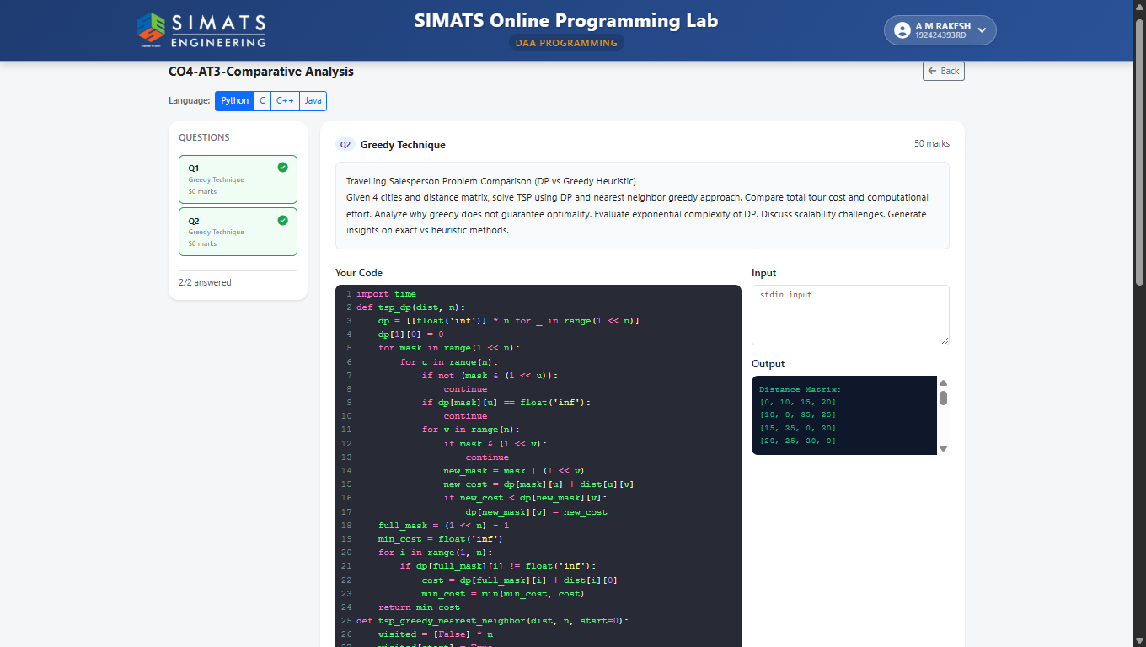
- Analyze time complexity

Brute Force: $O(n!)$ — Checks all permutations.
Dynamic Programming (Held-Karp): $O(n^{2}2^{n})$ — Solves $n2^{n}$ subproblems, each taking $O(n)$ time.
Greedy (Nearest Neighbor): $O(n^{2})$ — Visits $n$ cities, checking up to $n$ unvisited neighbors at each step.

- Analyze space complexity.

Brute Force: $O(n)$ — Stores only the current path and minimum distance.
Dynamic Programming (Held-Karp): $O(n2^{n})$ — Stores computed subproblem results for $n2^{n}$ state-city pairs.
Greedy (Nearest Neighbor): $O(n)$ — Tracks visited cities and the current path array.

- Compare the two DP formulations using a table.

Feature | Held-Karp (Subsets) | Standard Sequence / Shortest Path
State Definition | $C(S,j)$: Min cost visiting subset $S$, ending at city $j$ | $DP(i,j)$: Min cost path from $i$ to $j$
State Space | Exponential ($n2^{n}$) | Polynomial ($n^{2}$)
Time Complexity | $O(n^{2}2^{n})$ | $O(n^{3})$
Space Complexity | $O(n2^{n})$ | $O(n^{2})$
TSP Validity | Valid: Tracks visited set $S$ to enforce Hamiltonian cycle | Invalid: Cannot track visited nodes; allows loops/revisited cities

- Identify similarities between the two problems.
Graph Representation: Both model cities/nodes as vertices and routes/edges as weighted lines.
Optimization Goal: Both seek to minimize the sum of edge weights (total path cost).
Sequential Decisions: Both build paths step-by-step through successive node selections.
Subproblem Overlap: Both evaluate overlapping sub-paths (e.g., optimal path between intermediate node pairs).
Distance Matrix Input: Both rely on an N×N matrix representing distances between pairs.

- Identify differences in state definition and transitions.

State Definition
Held-Karp (TSP): $C(S,j)$ — Requires a subset of visited cities ($S$) and the current city ($j$). The state must track memory of history to prevent revisiting nodes and enforce a valid cycle.
Standard Shortest Path: $DP(u)$ — Requires only the current city ($u$). State depends strictly on the current node location, fully independent of prior history (Memoryless/Markovian property).
Transitions
Held-Karp (TSP):
$$C(S, j) = \min_{i \in S \setminus \{j\}} \left( C(S \setminus \{j\}, i) + D_{ij} \right)$$
Transitions step backward through subset removal, reducing the set size by one city per step.
Standard Shortest Path:
$DP(u)=\min_{v∈neighbors(u)}\left(D_{uv}+DP(v)\right)$
Transitions evaluate direct outgoing edges to adjacent nodes, operating without subset operations.

- Compare the DP state, transition, implementation, and complexity of both problems and provide a conclusion.

Feature | Traveling Salesperson Problem (TSP) | Shortest Path (e.g., Single-Source)
DP State | $C(S,j)$: Min cost visiting visited set $S$, ending at city $j$. | $D(u)$: Min cost path from source node to target node $u$.
Transition | $C(S, j) = \min_{i \in S \setminus \{j\}} \{ C(S \setminus \{j\}, i) + d_{ij} \}$ | $D(u)=\min_{v∈In(u)}\{D(v)+d_{vu}\}$
Implementation | Bitmasking DP or recursive memoization over subset sizes. | Topological sort (DAGs), relaxation loops (Bellman-Ford), or priority queues (Dijkstra).
Time Complexity | $O(n^{2}2^{n})$ | $O(E+VlogV)$

Code of Conduct
I A M RAKESH/192424393 (Name / Reg No) certify that this submission is my original work and that I have adhered to the guidelines specified for this assessment. I understand that any violation of academic integrity rules will result in disciplinary action.
Signature of the Student: 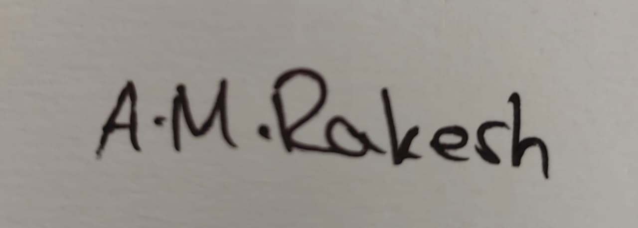

RUBRICS FOR CALCULATION

Comparative Analysis
Criteria | Weightage | Level 4 (Exemplary) | Level 3 (Proficient) | Level 2 (Developing) | Level 1 (Beginning)
Selection of Studies/Parameters | 20% | Selects highly relevant and diverse studies with well-defined comparison parameters | Selects relevant studies with minor gaps in parameter definition | Limited or partially relevant selection | Poor or inappropriate selection of studies
Comparison & Differentiation | 25% | Clearly compares multiple aspects (methods, results, limitations) with strong differentiation | Good comparison with minor gaps | Basic comparison with limited depth | No clear comparison; mostly descriptive
Critical Evaluation | 25% | Critically evaluates strengths, weaknesses, and implications with strong justification | Provides evaluation with some justification | Limited evaluation; lacks depth | No critical evaluation provided
Synthesis & Insight Generation | 20% | Generates meaningful insights and conclusions from comparisons | Some insights derived from comparison | Limited or unclear insights | No insights generated
Clarity | 10% | Information is clearly presented (tables/figures) with logical structure | Generally clear with minor issues | Presentation lacks clarity or structure | Poor presentation and difficult to understand

Mark Evaluation:
Questions | Selection of Studies/Parameters (20) | Comparison & Differentiation  (25) | Critical Evaluation (25) | Synthesis & Insight Generation  (20) | Clarity (10) | Total Marks  (Each - 50)
Q1
Q2
Overall Total

Faculty In-charge | Course Coordinator | Head of Department
Name: __________________  Signature: _______________ | Signature: _______________ | Signature: _______________
Date: ___________________ | Date: ___________________ | Date: ___________________

